**AI-Powered Health Assistant**

A Project Report

submitted in partial fulfillment of the requirements

of

AICTE Internship on AI: Transformative Learning

with

TechSaksham – A joint CSR initiative of Microsoft & SAP

by

**Aakash Jangeeti, aakashroyal1710@gmail.com**

Under the Guidance of

**Jay Rathod**

**ACKNOWLEDGEMENT**

I would like to take this opportunity to sincerely thank everyone who has supported me, both directly and indirectly, throughout this project. Their guidance, encouragement, and assistance have been invaluable in making this work possible.

First and foremost, I extend my deepest gratitude to my supervisor Jay Rathod,for being an incredible mentor and guide. His constant support, insightful advice, and constructive feedback have been the driving forces behind the successful completion of this project. His encouragement kept me motivated, and his belief in my potential inspired me to push my limits and strive for excellence.

Throughout this journey, he has been more than just an academic advisor; he has been a source of knowledge, inspiration, and wisdom. His mentorship has not only helped me shape this project but has also contributed to my overall growth as a student and as an aspiring professional. The discussions, guidance, and valuable lessons I received from him extended far beyond this project and have positively influenced my approach to learning and problem-solving.

I would also like to acknowledge the support of my friends, classmates, and faculty members who have contributed in different ways. Their suggestions, discussions, and moral support have been instrumental in keeping me on track.

Lastly, I express my heartfelt appreciation to my family for their constant encouragement and unwavering belief in me. Their patience, love, and emotional support have been my strength during challenging times.

This project is a result of the collective effort and guidance I have received, and I am truly grateful to each person who has played a role in making it a reality.

#### **ABSTRACT**

In today’s fast-paced world, access to immediate and reliable healthcare information is crucial. Many individuals seek preliminary medical guidance online, often encountering unreliable or misleading sources. To address this issue, this project presents an **AI Health Assistant**, a chatbot designed to provide users with quick and informative health-related responses.

**Problem Statement:**  
People frequently rely on the internet for medical advice, leading to misinformation and self-diagnosis errors. There is a need for an AI-powered system that can offer accurate, general healthcare guidance while encouraging users to consult professionals when necessary.

**Objectives:**

* Develop a user-friendly AI chatbot for healthcare assistance.
* Provide basic information on symptoms, medications, and appointments.
* Integrate an NLP model to generate relevant responses.
* Ensure the chatbot promotes consulting healthcare professionals for critical issues.

**Methodology:**  
The Chatbot is built using **Streamlit** for the frontend and **Transformers (DistilGPT-2)** for AI-driven responses. The **NLTK** library is used for natural language processing, including tokenization and stopword removal. The system identifies key terms in user queries and either provides predefined responses for medical topics or generates responses using AI.

**Key Results:**  
The Chatbot successfully interacts with users, offering relevant responses to healthcare-related queries. It efficiently identifies symptoms, medication-related concerns, and appointment scheduling requests. Users receive AI-generated answers for general inquiries, improving engagement.

**Conclusion:**  
This project demonstrates the potential of AI in assisting users with basic healthcare guidance. While not a replacement for professional consultation, the chatbot serves as a reliable first step for users seeking preliminary health information. Future improvements could involve integrating a medical database and real-time doctor consultations to enhance accuracy and reliability.

**TABLE OF CONTENT**

**Abstract I**

**Chapter 1.**  **Introduction 1**

1.1 Problem Statement 1

1.2 Motivation 1

1.3 Objectives 2

1.4. Scope of the Project 2

**Chapter 2.**  **Literature Survey 3**

**Chapter 3.**  **Proposed Methodology**

**Chapter 4.**  **Implementation and Results**

**Chapter 5. Discussion and Conclusion**

**References**

**LIST OF FIGURES**

|  |  |  |
| --- | --- | --- |
| **Figure No.** | **Figure Caption** | **Page No.** |
|  | **Proposed Solution Architecture** | **5** |
|  | Result Image without Inputs | **7** |
|  | Result Image with Inputs and Outputs | **7** |
|  |  |  |
|  |  |  |
|  |  |  |
|  |  |  |
|  |  |  |
|  |  |  |

**LIST OF TABLES**

|  |  |  |
| --- | --- | --- |
| **Table. No.** | **Table Caption** | **Page No.** |
|  |  |  |
|  |  |  |
|  |  |  |
|  |  |  |
|  |  |  |
|  |  |  |
|  |  |  |
|  |  |  |
|  |  |  |

**CHAPTER 1**

**Introduction**

### ****1.1 Problem Statement****

In the modern digital age, people frequently search for health-related information online. However, this often leads to misinformation, self-diagnosis errors, and confusion due to the vast and unverified sources available. Many individuals, especially in remote areas, lack immediate access to medical professionals and rely on online sources that may not be credible. Additionally, searching for symptoms on the internet can cause unnecessary anxiety or delay professional consultation for serious conditions.

This issue is significant because improper self-diagnosis and self-medication can lead to severe health risks, including incorrect treatments, worsening conditions, and harmful drug interactions. There is a growing need for an AI-driven healthcare assistant that can provide users with reliable preliminary guidance, directing them toward appropriate medical advice while minimizing the risks associated with misinformation.

### ****1.2 Motivation****

The inspiration behind this project stems from the increasing dependency on online health information and the lack of immediate access to medical professionals in many regions. Many people seek quick answers about symptoms, medications, and health conditions but struggle to find accurate and trustworthy sources.

The potential applications of this AI-powered health assistant are vast:

* It can serve as an initial step for users seeking health-related information.
* It can provide general guidance on symptoms and medications while encouraging professional consultation.
* It can be integrated into healthcare platforms, clinics, or mobile applications to assist users 24/7.

The impact of this project lies in making healthcare guidance more accessible, reducing misinformation, and helping users make informed decisions about their well-being.

### ****1.3 Objective****

The primary objectives of this project are:

* To develop an AI-powered healthcare assistant that provides users with basic medical guidance.
* To use natural language processing (NLP) for understanding user queries and generating relevant responses.
* To offer predefined responses for common healthcare concerns such as symptoms, medication usage, and appointments.
* To encourage users to seek professional medical advice when necessary.
* To ensure a user-friendly interface for seamless interaction.

### ****1.4 Scope of the Project****

The scope of this project includes:

* Implementing a chatbot that can provide basic information about symptoms, medications, and healthcare practices.
* Utilizing NLP and AI-based text generation models to enhance user interactions.
* Deploying the system as a web-based application using Streamlit for accessibility.

**Limitations:**

* The AI assistant does not replace professional medical advice and should not be used for diagnosing serious conditions.
* The chatbot's responses are based on predefined logic and AI-generated text, which may not always provide comprehensive medical guidance.
* The system does not integrate with real-time medical databases or offer live consultations with doctors.

**CHAPTER 2**

**Literature Survey**

### ****2.1 Review of Relevant Literature and Previous Work****

The use of artificial intelligence (AI) in healthcare has grown significantly in recent years. AI-driven chatbots and virtual assistants have been developed to provide users with basic medical guidance, symptom checking, and preliminary diagnosis suggestions. Various studies highlight the effectiveness of AI models in healthcare assistance, focusing on Natural Language Processing (NLP) and machine learning algorithms to improve user interactions.

Several AI-based healthcare chatbots, such as Babylon Health, Buoy Health, and Ada, have been developed to assist users in understanding symptoms and seeking medical guidance. These chatbots leverage deep learning and medical databases to provide recommendations. However, most of these systems require extensive training on medical datasets and access to large-scale healthcare records, which may not be feasible for all applications.

### ****2.2 Existing Models, Techniques, and Methodologies****

Several methodologies have been used in AI-based health assistants:

* **Rule-Based Chatbots**: These rely on predefined responses based on user input keywords. They are simple but lack adaptability.
* **Machine Learning-Based Chatbots**: These use trained models to classify user queries and generate appropriate responses.
* **Deep Learning and NLP Models**: Transformer-based models like **GPT-3, BERT, and DistilGPT-2** are used to generate human-like responses by understanding the context of user queries.
* **Medical Symptom Checker APIs**: Some applications integrate existing medical APIs to provide symptom analysis and suggest possible conditions.

### ****2.3 Gaps and Limitations in Existing Solutions****

Despite advancements in AI-driven healthcare chatbots, existing solutions have several limitations:

* **Limited Accuracy in Medical Advice**: AI chatbots cannot fully replace professional healthcare providers and may give generalized or inaccurate recommendations.
* **Dependence on Large Medical Datasets**: Most advanced chatbots require extensive access to medical databases, which can be restricted due to privacy concerns.
* **Lack of Personalized Interaction**: Many chatbots provide one-size-fits-all answers without considering the user’s medical history.
* **High Computational Costs**: Advanced AI models require significant computational power and resources, making them less accessible for small-scale applications.

### ****How This Project Addresses These Gaps****

* **General Guidance Instead of Diagnosis**: Unlike symptom checkers that attempt to diagnose conditions, this chatbot focuses on providing general information and encouraging users to consult a professional.
* **Lightweight and User-Friendly**: The project uses **DistilGPT-2**, a lightweight NLP model, combined with **Streamlit**, making it accessible and easy to use.
* **Customizable Knowledge Base**: The chatbot can be expanded with more predefined responses to enhance accuracy without requiring a vast medical dataset.
* **Encouragement of Professional Consultation**: Instead of replacing medical professionals, the chatbot guides users toward seeking expert advice when needed.

**CHAPTER 3**

**Proposed Methodology**

* 1. **System Design**

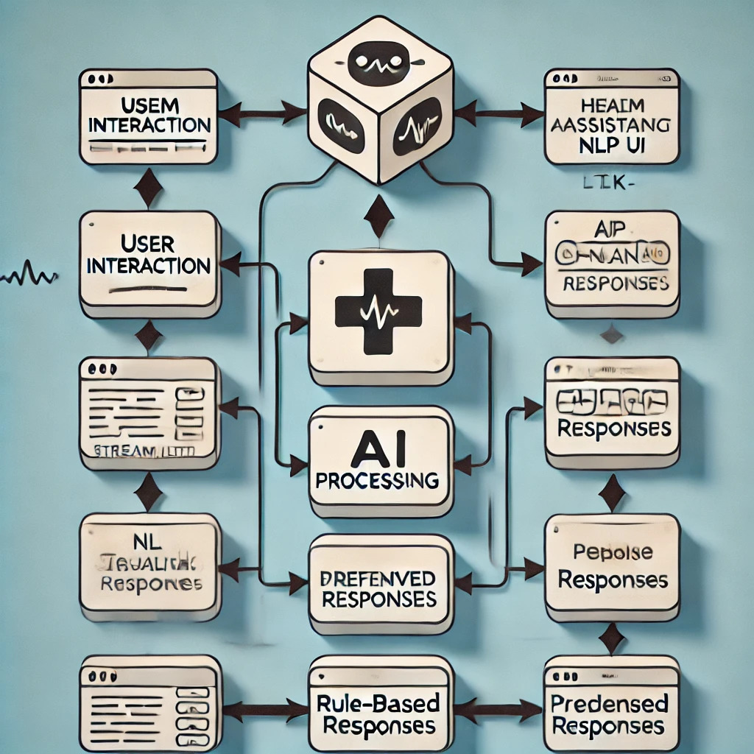

#### **Proposed Solution Architecture**

Below is the high-level design of the AI Health Assistant chatbot:

1. **User Interface (Frontend - Streamlit)**
   * Users interact with the chatbot through a simple and intuitive web-based UI.
   * A text input field allows users to ask health-related questions.
2. **Natural Language Processing (NLP) Module**
   * **NLTK** (Natural Language Toolkit) processes user queries, tokenizes text, and removes unnecessary stopwords.
   * This step ensures cleaner input for better response generation.
3. **AI Model (DistilGPT-2)**
   * **Transformers-based AI model (DistilGPT-2)** generates responses to user queries.
   * The model is fine-tuned to provide relevant and coherent answers.
4. **Predefined Response Handler**
   * Some questions, such as those related to symptoms, appointments, and medications, are handled using predefined rules.
   * This ensures users receive quick and structured responses for critical queries.
5. **Output Generation**
   * The chatbot displays the response in real-time via the Streamlit UI.
   * Users can view AI-generated suggestions or predefined responses.
   1. **Requirement Specification**

To implement the AI Health Assistant, the following tools and technologies are required:

#### **3.2.1 Hardware Requirements:**

* **Processor:** Intel Core i3 or higher
* **RAM:** 8GB (minimum), 16GB (recommended)
* **Storage:** 10GB free space
* **GPU (Optional):** If running advanced AI models, a GPU (NVIDIA GTX 1050 or better) is recommended.

#### **3.2.2 Software Requirements:**

* **Programming Language:** Python
* **Libraries & Frameworks:**
  + streamlit (for UI development)
  + transformers (for AI model)
  + nltk (for text preprocessing)
  + tensorflow (for deep learning capabilities)
  + tf-keras (for model integration, if needed)
* **Development Environment:** VS Code / Jupyter Notebook
* **Operating System:** Windows, Linux, or macOS
* **Package Manager:** pip (for installing dependencies)

**CHAPTER 4**

**Implementation and Result**

* 1. **Snap Shots of Result:**

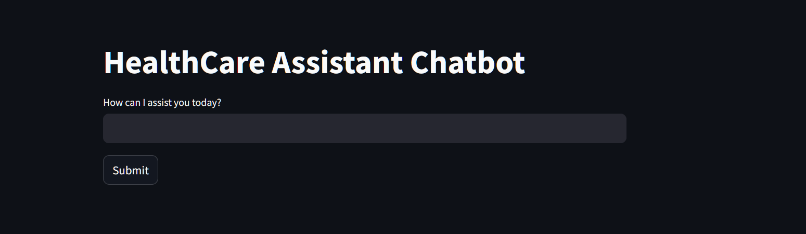

The above image represents the AI Healthcare Assistant as a web page , where the user has to input his symptoms to get the desired medicine .

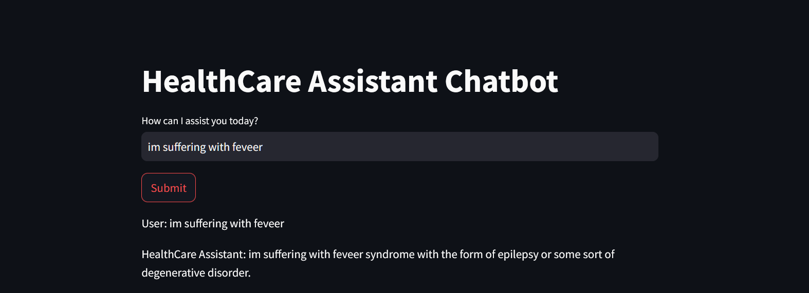

The above image represents the AI Health Assistant as a web page , highlighting the way it responds to each and every user.

* 1. **GitHub Link for Code:**

**CHAPTER 5**

**Discussion and Conclusion**

* 1. **Future Work:**

While the AI Health Assistant successfully provides users with basic healthcare guidance, there are several areas for future improvements:

1. **Integration with Medical Databases:**
   * Incorporating verified medical resources such as WHO, CDC, or hospital databases to improve response accuracy and reliability.
2. **Advanced AI Model Training:**
   * Fine-tuning the AI model using medical datasets to provide more precise responses tailored to healthcare-related queries.
3. **Voice Assistance Feature:**
   * Implementing speech-to-text and text-to-speech capabilities to make the chatbot accessible for users who prefer voice interactions.
4. **Multilingual Support:**
   * Expanding the chatbot’s capabilities to support multiple languages, making healthcare guidance more inclusive for diverse user groups.
5. **Integration with Telemedicine Services:**
   * Enabling users to connect with real doctors through virtual consultations when necessary.
6. **Mobile App Development:**
   * Extending the AI Health Assistant to mobile applications for better accessibility and convenience.
7. **Data Privacy & Security Measures:**
   * Implementing secure data storage and encryption methods to protect user information while maintaining ethical AI practices.

By addressing these areas, the AI Health Assistant can evolve into a more comprehensive and reliable healthcare support tool in the future.

* 1. **Conclusion:**

The AI Health Assistant project demonstrates the potential of artificial intelligence in providing preliminary healthcare guidance. This chatbot assists users by offering responses to common medical queries, including symptoms, medications, and general healthcare advice. By utilizing **NLP (Natural Language Processing)** and **AI-driven text generation (DistilGPT-2)**, the system enhances user interaction and accessibility.

While the chatbot does not replace professional medical consultation, it serves as a helpful first step in guiding users toward appropriate healthcare decisions. The project contributes to the field of AI-driven healthcare solutions by addressing the issue of misinformation and providing a user-friendly interface for quick access to general health information.

Future enhancements, such as integrating verified medical databases, enabling voice assistance, and supporting multilingual interactions, can significantly improve its effectiveness. Overall, this project highlights the impact of AI in bridging the gap between users and essential healthcare knowledge, ensuring better awareness and decision-making in health-related matters.

**REFERENCES**

• **Vaswani, A., Shazeer, N., Parmar, N., Uszkoreit, J., Jones, L., Gomez, A. N., Kaiser, Ł., & Polosukhin, I.** (2017). Attention is All You Need. NeurIPS. Retrieved from <https://arxiv.org/abs/1706.03762>

• **Devlin, J., Chang, M. W., Lee, K., & Toutanova, K.** (2019). BERT: Pre-training of Deep Bidirectional Transformers for Language Understanding. NAACL-HLT. Retrieved from <https://arxiv.org/abs/1810.04805>

• **Wolf, T., Debut, L., Sanh, V., Chaumond, J., Delangue, C., Moi, A., ... & Rush, A. M.** (2020). Transformers: State-of-the-Art Natural Language Processing. Retrieved from <https://arxiv.org/abs/1910.03771>

• **Brown, T., Mann, B., Ryder, N., Subbiah, M., Kaplan, J., Dhariwal, P., ... & Amodei, D.** (2020). Language Models are Few-Shot Learners (GPT-3). NeurIPS. Retrieved from <https://arxiv.org/abs/2005.14165>

• **Bird, S., Klein, E., & Loper, E.** (2009). Natural Language Processing with Python (NLTK). O'Reilly Media.

• **World Health Organization (WHO).** (2022). Health misinformation and its impact on public health. Retrieved from <https://www.who.int>

• **Centers for Disease Control and Prevention (CDC).** (2022). Guidelines on Reliable Medical Information Online. Retrieved from <https://www.cdc.gov>

• **Streamlit Documentation.** (2023). Building Interactive AI-Powered Web Apps with Streamlit. Retrieved from https://docs.streamlit.io

• **Hugging Face.** (2023). Transformers Library for NLP. Retrieved from https://huggingface.co/docs/transformers/index

• **TensorFlow.** (2023). Deep Learning Framework for AI Applications. Retrieved from <https://www.tensorflow.org>